Goma Limpia Crist. Etore 35 Cms
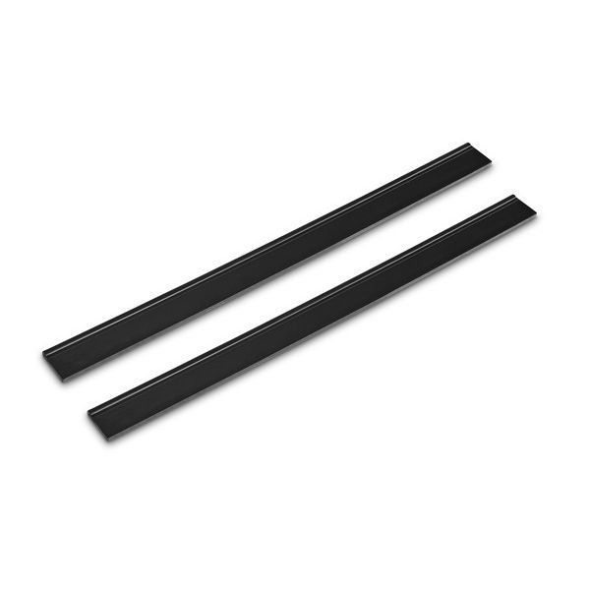
Goma limpia cristales de 35 cms.

